**Configure Knife**

**Step 1 : Download starter kit from chef server on your desktop**

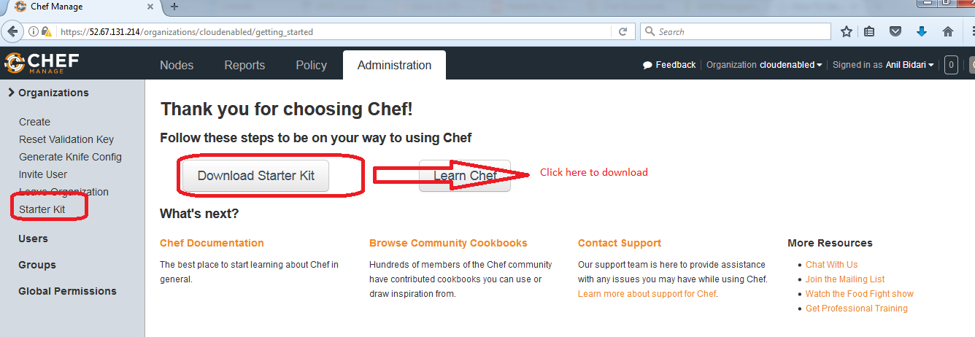

**Step 1 A : Winscp the start kit to your chef-workstation**

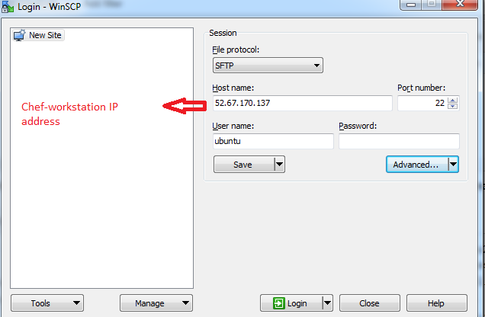

**Step 1 C : Instlal unzip package and unzip chef starter kit**

# yum install unzip

**and**

unzip chef-starter.zip

**Step 2: Check clients (**This first attempt should fail with an error that looks like this**)**

# cd /home/ec2-user/chef-repo

# knife client list

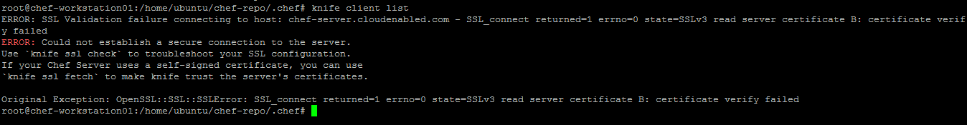

**Step 3: Fetch ssl certificate from chef-server**

# knife ssl fetch

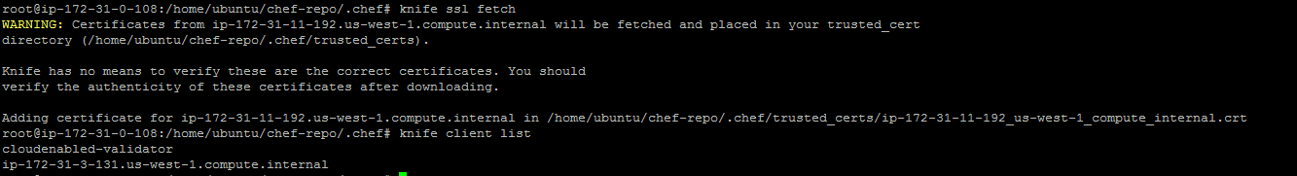

**Step 4 : ensure that you have recived the ssl cert on your workstation**

# ls -l /home/ec2-user/chef-repo/.chef/trusted_certs/



**Step 5 : Once you try to list the ( you should get error as below)**

# knife client list



**Step 6 : List cookbook o chef server ( none at this moment)**

knife cookbook list